Welcome!
Date
Name
Spouse
Address
City
State Zip _________
Email

Please Contact By
❑ Card  Phone  Visit

Telephone Best Time to Call
Home ______________
Work ______________

Guest: First Time Second Time
Are you a church member: yes no
Church
City, State

Circle Appropriate Age/Grade Group(s)
Preschool: Ages: B-1 2-3 4-5
Children: Grades: K 1 2 3 4 5 6
Youth: Grades: 7 8 9 10 11 12
Adults: Ages:18-29 30s 40s 50s 60s+

How did you learn about our church?
Newspaper Friend Yellow Pages Mail
Other

I am a guest of:

New in the Community? Yes No
Names & ages of children at home

Weekly Service & Activity Schedule

May 10, 2015
9:45 a.m. Sunday School
11:00 a.m. Morning Worship Service
No Worship Service this Evening

Week of May 10, 2015

Wednesday 7:00 p.m. Adult Prayer & Bible Study
Thursday 10:00 am Adult Fellowship

Upcoming Events
May
14……………………………….….………..Adult Fellowship
17….….….Independence Assoc. Music Festival (Brenham)
24……………………………….……………Veteran’s Service
24…………………………………………….Business Meeting
31………………………………………….KSBC Homecoming

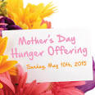
Give a special offering today as part of the Texas Baptist Hunger Offering.


If anyone is graduating this spring or summer, or if you graduated since the last time we had a Grad Banquet, please let Geneva Davis or Otisann McManus know. That includes high school, college, or trade school.

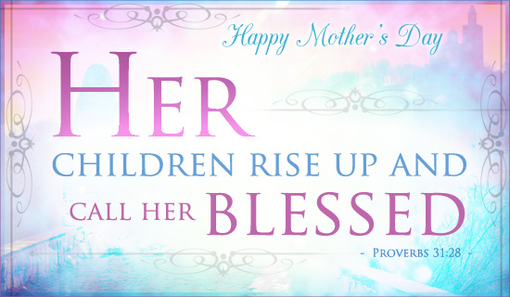

Knobbs Springs Baptist Church

May 10, 2015

Church Information:

KnobbsSpringsBC.com KnobbsSpringsBaptist@gmail.com
1662 CR 305, McDade, Texas 78650 512-273-2743
David Atwood, Pastor Cell 512-470-5098
Home 512-856-2819
Patti Radford, Office Manager Cell 512-968-7821

